TECHNICAL REPORT ON STUDENT INDUSTRIAL WORK EXPERIENCE SCHEME (SIWES)

HELD AT
PHYSICAL PLANNING AND DEVELOPMENT ADSU,
MUBI, ADAMAWA STATE

FROM: 6TH OCTOBER, 2024
TO: 29TH JANUARY, 2025

TITLE PAGE

BY
JOSEPH LUKA
(SE/ARC/ND/23/026)

SUBMITTED TO THE DEPARTMENT OF ARCHITECTURAL TECHNOLOGY, FEDERAL POLYTECHNIC MUBI, IN PARTIAL FULFILLMENT OF THE REQUIREMENT FOR THE AWARD OF NATIONAL DIPLOMA (ND) IN ARCHITECTURAL TECHNOLOGY

APRIL, 2025

DECLARATION
This is to declare that I, JOSEPH LUKA with registration number SE/ARC/ND/23/026 undertook my four months SIWES at Physical Planning and Development Adamawa State University, Mubi, Adamawa State and have acquired all the experience compiled in this report in the course of my SIWES.

……………………………….. ……………………………
JOSEPH LUKA Sign/Date

CERTIFICATION
This is to certify that this report compiled by JOSEPH LUKA (SE/ARC/ND/23/026) meets the requirement of governing the award of National Diploma (ND) of the Federal Polytechnic Mubi, and is approved by:

………………………………. ……………………
Name of Supervisor Date
Departmental Supervisor

………………………………. ……………………
Arc. Daniel Barka Date
Departmental SIWES Coordinator

…………………………………. ……………………
Arc. Mohammed Usman Date
Head of Department

DEDICATION
I dedicate this technical report to my parents, my sisters and colleagues and to all those that supported me throughout the industrial training.

ACKNOWLEDGEMENTS
My sincere appreciation goes to Almighty God for his guidance, protection throughout the period of my Industrial Training.
My appreciation goes to my beloved parent for the motivation, prayers and financial support towards my SIWES exercise.
My special thanks go to my beloved brothers and sisters for all their care and support throughout my industrial training.
I wish to thank the staff of Architectural Technology department in Federal Polytechnic, Mubi.
I want to also thank my colleagues and others; I really appreciate your efforts.

TABLE OF CONTENTS
TITLE PAGE i
DECLARATION ii
CERTIFICATION iii
DEDICATION iv
ACKNOWLEDGEMENTS v
TABLE OF CONTENTS vi
ABSTRACT viii
CHAPTER ONE 1
1.0 INTRODUCTION 1
1.1 Aim and objective of SIWES 1
1.2 Brief history of SIWES and ITF in Nigeria 2
1.3 Significance of SIWES to students 2
CHAPTER TWO 3
2.1 Brief History of Physical Planning and Development, Adamawa State University, Mubi, Adamawa State 3
2.2 COMPANY ORGANOGRAM 3
CHAPTER THREE 4
3.0 DESCRIPTION OF WORK EXPERIENCE 4
3.1 SITE CLEARANCE 4
3.2 SETTING OUT 4
3.4 WALL CONSTRUCTION 8
3.5 DOOR AND WINDOW FRAMING 10
3.6 ROOFING CONSTRUCTION 12
3.7 CANTILEVER CONSTRUCTION 14
CHAPTER FOUR 16
4.0 SUMMARY, CONCLUSION AND RECOMMENDATIONS 16
4.1 PROBLEMS OBSERVED DURING MY PROGRAM 16
4.2 SUMMARY 16
4.3 CONCLUSION 17
4.4 RECOMMENDATIONS 17
REFERENCES 18

ABSTRACT
The report summarises the result of work done during my SIWES experience, the technical report consists of four chapters; introduction, history and criteria’s of SIWES; aims and objectives, historical background, organizational structure of the organization in chapter two, while chapter three consist of the work actually carried out during the SIWES programme and lastly chapter four consist of the summary, conclusions and recommendation.

CHAPTER ONE

1.0 INTRODUCTION
The acronym (SIWES) meaning “Student Industrial Work Experience Scheme” is a skill training designed to expose and prepare student in institution of higher for industrial working situation they may likely meet after graduation. The scheme is meant to train student on the method of work and the experience needed in handling the equipment and machines may not to be available in their institution. The scheme is financed by the Federal Government and operators through Industrial Training Fund (ITF), Ogwo, (2001) and operates with National University Commission (NUC), National Board of Technical Education (NBTE), and National Commission for College of Education (NCCE) and industries. However, SIWES also expose the student to many practical works which the institution did not treat in details without plastering what the institution taught theoretically into practical. A point from academic obtained. SIWES assist the student to understand the nature of his/her work in future.

1.1 Aim and objective of SIWES
ITF initiates SIWES with the sole aim of: Exposing student with the practical experience related to the theoretical knowledge acquired in school. Bridging the gap between theoretical learning and practical work situation.
- To make industries/organization to have confidence in the abilities and capacities of the graduates. SIWES helps the industries to evaluate the prospective employees and give feedback to the institution.
- It helps the student to gain work and also have experience and confidence as a result if successful completion of a given job assigned to them.
- To enlist and strengthen the employers’ involvement in the institution activities and in the entire educational process of preparing the student for meaningful and productive employment into industries.
- It provides an avenue for student in the Nigerian University and Polytechnics to acquire industrial skill and experience in their course of study.
- Development for greater understanding in other people and proffers skills in human relations.

1.2 Brief history of SIWES and ITF in Nigeria
It was said by Dr. Azikiwe Nnamdi, the one president of Nigeria that the practice of work but they all have the same goal that they all want to achieve in countries like china. They established within the premises of institution to provide real life situation, lack of practical skill of locally trained engineers and technologies. the chine way and condition of SIWES is that all institution must give student real life working experience in industrial works. Lecturers are involved in the industrial activities rendering constant services. So, all these countries have their own way of conducting the scheme but all lye on the same goal. And in Nigeria, the history of SIWES can be traced by the history of IITF which is the backbone of SIWES. ITF was established in 1974 under degree of 47 of 1971. It was a body established by the Federal Government of Nigeria and was given responsibility of training indigenous Nigerians. The establishment of the body became necessary due to high demand of Nigeria to take up the vacant positions created in various sector of the economy after the colonial masters have departed. Therefore, the Federal Government discovered that it is easier to train students that are skilled in school to be trained and meet up with gaps in the Nigerian economy and a scheme was established to care for such training and it was named Student Industrial Work Experience Scheme (SIWES).

1.3 Significance of SIWES to students
Principles taught in the classroom are vein forced given concrete applications on the industrial assignment and students is able to see the relevance of their students which increase their motivation. It helps in given students the knowledge on the types of work to do after his/her graduation. SIWES given students opportunity for a change of environment as they move their institution to the place of attachment which changes the routine types of environment to a word of work. It helps in connecting the institution and the industrial their relationship the introduction of SIWES.

CHAPTER TWO

2.1 Brief History of Physical Planning and Development, Adamawa State University, Mubi, Adamawa State
Adamawa State University is located in Mubi, in the Northern Senatorial District of Adamawa State, Nigeria. It was established in 2002 by the Adamawa State University Law No. 10 of 2001. The title caption of the university is "Towards ensuring rapid development and transformation of the State". The current vice chancellor is Dr Stephen Lagu, has various department comprises of technical department, workers department, and physical planning department.
The physical planning directorate current has 2 1 staff as follows:
- Architects - 4
- Civil engineers - 2
- Builder - 1
- Town planners - 4
- Quantity surveyor - 3
- Craft men - 3
- Admin stall - 7

2.2 COMPANY ORGANOGRAM
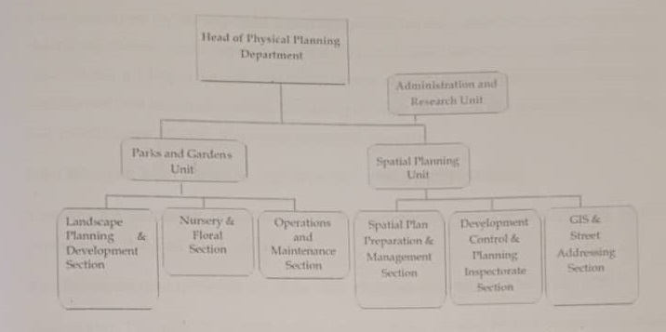
Figure 2.1: Organogram

CHAPTER THREE

3.0 DESCRIPTION OF WORK EXPERIENCE

3.1 SITE CLEARANCE
For the site clearance process, our team took several key steps to ensure the site was ready for construction. First, we gathered all necessary equipment, including shovels, chainsaws, and safety gear, and reviewed the site plan to ensure we understood the requirements. We made sure to obtain the necessary permits and took the time to discuss safety precautions. Next, we cleared the vegetation, carefully handling any environmentally sensitive plants. Construction debris and obstacles like rocks and concrete slabs were removed using heavy machinery, ensuring the site was free of obstructions. Excavation and grading were carried out to level the site and guarantee proper drainage for a solid foundation. Throughout the process, we managed waste responsibly, disposing of both hazardous and non-hazardous materials according to regulations. Finally, a thorough inspection was performed to ensure the site was clean, safe, and fully prepared for the next phase of development.

3.2 SETTING OUT
The Square Method was used to accurately set out rectangular or square buildings by ensuring all corners formed perfect right angles. It was based on the 3:4:5 rule from Pythagoras’ Theorem. The process involved measuring and pegging out straight lines, adjusting angles to form right corners, and confirming accuracy by checking diagonals. This method helped prevent construction errors and ensured the building's structural integrity. As noted by an engineer, accurate calculations during setting out were crucial for the building’s durability
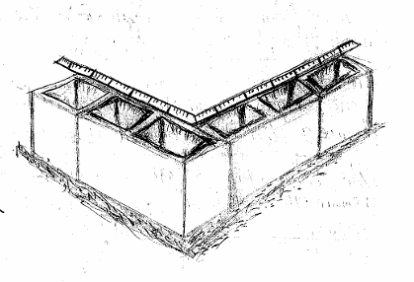
Plate 3.1: Setting out

3.3 EXCAVATION OF FOUNDATION
Excavation can be defined as the process of digging a soil surface or trench for foundation lay into trench. It is also the process of removing top soil for foundation trenches. Excavation work is an important part of building operation that commences immediately after setting out the width of excavation for foundation trenches is marked out on the profile and then transferred to the ground. Excavation must be carried out carefully to ensure safety of workers.
Excavation can be done using two methods mechanical and manual. In small construction we normally use manual method while in large construction we use mechanical e.g. like road construction. Excavation work were carried out manually where unskilled labourer where involved with digger, shovels, head pan and wheel barrow. The following factors must be considered when carrying out any excavation work.
- Nature of the soil
- The width and depth of foundation
- Climatic condition at the time of excavation
- The water table of the soil
- The period excavation work is expected to be left open.
- The effect of excavation on existing adjacent structure.
As the engineer and the mason goes to set basket, I was keeping an eye on how the beams were set. When digging the basket some places were 1.2 while some other places were 1.4 by 1.4 because of the type of soil on the site. When putting the basket in a poor soil, cement and sharp sand is mixed out before putting the basket to avoid rusting.

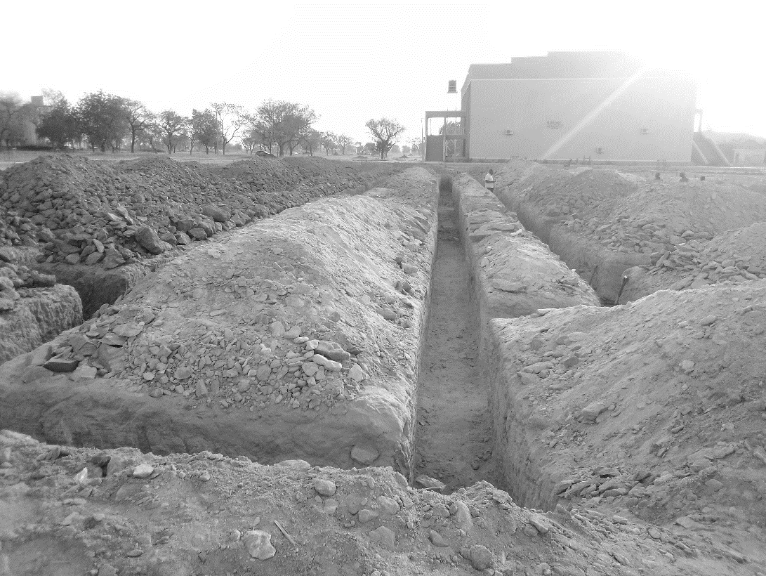

Plate 3.2: Foundation and Excavation

3.4 WALL CONSTRUCTION
Following the successful completion of the ground floor slab, the construction team transitioned to the upper floor wall construction, an essential phase that contributes significantly to the vertical load-bearing structure of the building. This stage involves careful planning and execution to ensure alignment with architectural and structural specifications. We began by accurately setting out the wall positions on the cured slab using chalk lines and measuring tools, following the dimensions provided in the architectural drawings. This step was critical to ensure proper wall alignment and consistency throughout the upper floor.
The block laying process commenced with skilled masons placing the first course of blocks along the perimeter and internal walls. Special attention was given to ensuring that the first course was level and plumb, as any errors would affect the integrity of the entire wall. A mortar mix, typically in the ratio of 1:6 (cement to sand), was used to bond the blocks. Builders applied the mortar evenly and maintained uniform joint thickness (usually 10–15 mm) for aesthetic and structural consistency.
As construction progressed vertically, reinforcement bars (starter bars) extended from the ground floor were integrated into the blockwork to ensure continuity and structural stability, especially around load-bearing walls and columns. Horizontal reinforcement such as block mesh or steel rods was also inserted at specified heights to enhance the tensile strength of the walls and reduce the risk of cracks. Lintel beams were constructed above all door and window openings to distribute the load and prevent cracking. These were cast in-situ using formwork, reinforcement, and concrete, similar to beam construction.
At regular intervals, the site engineer supervised the work to ensure that blocks were laid plumb, walls were aligned vertically and horizontally, and openings were accurately positioned as per the drawings. Wall ties, conduits for electrical fittings, and plumbing sleeves were installed concurrently to reduce the need for chiseling after wall completion. Once the desired wall height was reached, the walls were cured periodically by spraying water, especially during hot weather, to prevent premature drying and to enhance the strength of the mortar. The upper floor wall construction was thus completed with close attention to detail, ensuring both structural integrity and alignment with design requirements.
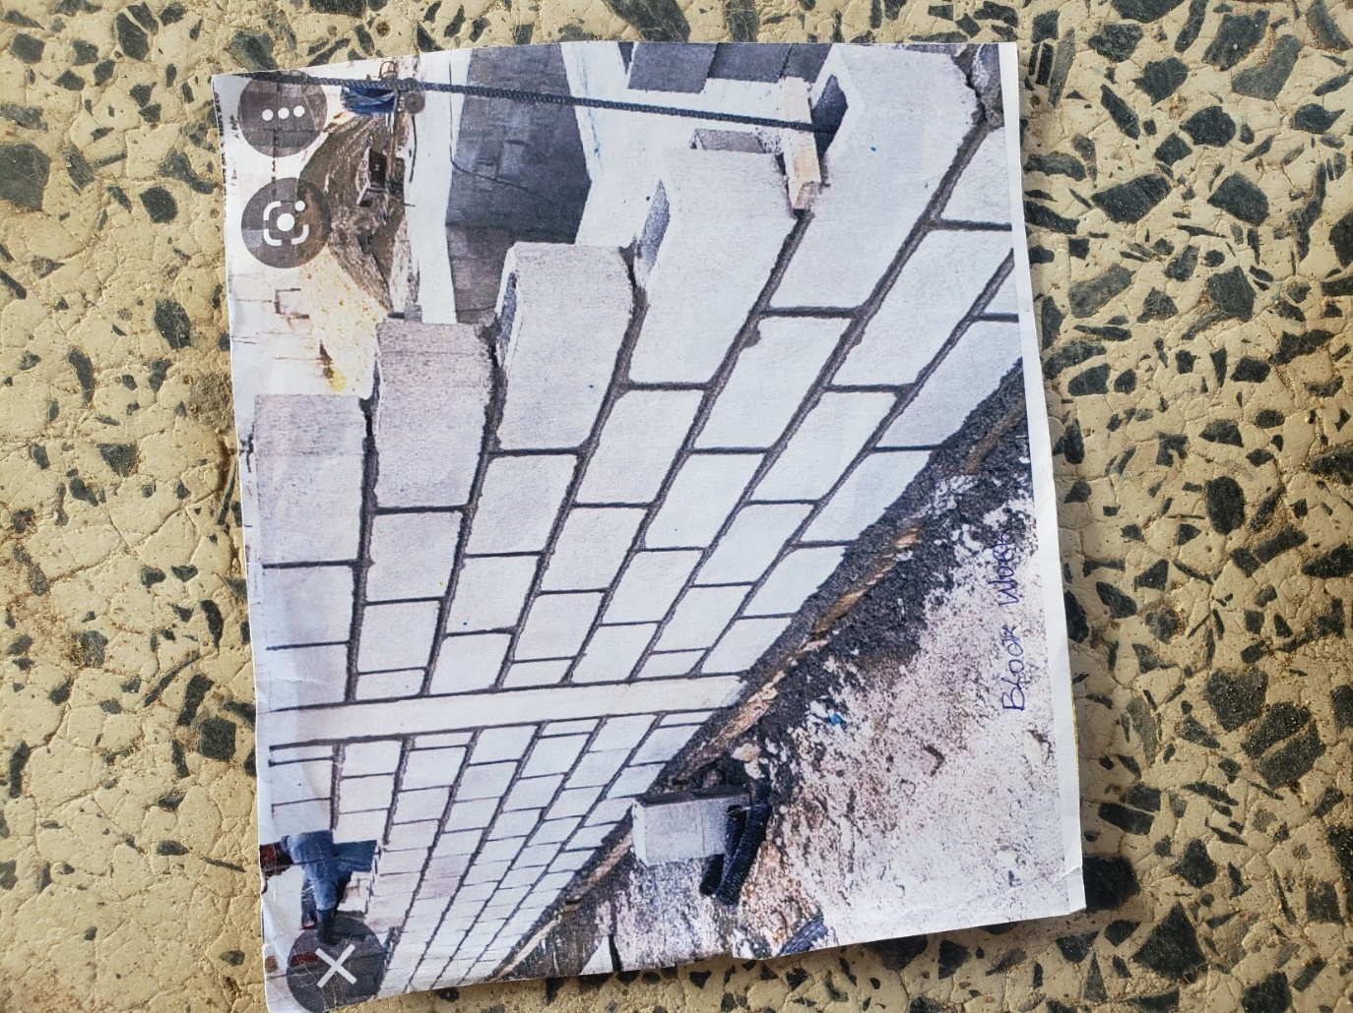

Plate 3.3: Wall Construction

3.5 DOOR AND WINDOW FRAMING
The installation of door and window frames, an important step in preparing the structure for finishing works such as door and window fittings, plastering, and painting. This stage required precision and adherence to both architectural and structural specifications to ensure the correct alignment, durability, and functionality of all openings. The process began with a thorough verification of door and window openings previously left in the wall during blockwork. Measurements were taken using tape and spirit levels to confirm that all openings corresponded with the dimensions outlined in the architectural drawings.
Once verified, the installation of frames commenced. Depending on the design and functional requirements, frames made from wood, metal, or aluminum were selected. Wooden frames, commonly used in residential buildings, were treated with anti-termite solution to prolong lifespan and prevent pest infestation. Frames were then carefully positioned within the openings. Masons and carpenters used plumb bobs and spirit levels to ensure the frames were perfectly vertical (plumb) and square. Any misalignment at this stage could lead to operational issues with doors or windows later on.
To ensure stability, frames were anchored to the surrounding blockwork using metal holdfasts or steel straps. These were embedded securely into the wall, either through mortar joints or block cavities. In cases involving metal or aluminum frames, expansion bolts or screws with wall plugs were used for firm attachment. During installation, temporary bracing was applied to hold the frames in the correct position until the surrounding plastering and construction work provided permanent support. Care was also taken to ensure that thresholds were level and the frame’s edges aligned with the wall surfaces, especially where plastering or finishing would later take place.
Additionally, electrical and plumbing provisions running near the frames were checked to prevent future obstruction during door or window operation. Protective coverings were placed over frames to prevent damage or staining during subsequent construction activities. By the end of this phase, all door and window frames were securely fixed, properly aligned, and ready for the fitting of shutters, glass, or louver panels during the finishing stage. This careful execution ensured both aesthetics and operational performance in the final building.

3.6 ROOFING CONSTRUCTION
Following the successful completion of the wall construction, the project transitioned to the roofing phase, a crucial stage that provides protection against weather elements, enhances building aesthetics, and contributes to the structural enclosure of the building. Roofing must be executed with precision, using quality materials and skilled labor to ensure durability, water-tightness, and alignment with the architectural design. Before construction began, the roof design—including pitch, span, truss type, and covering material was carefully reviewed in line with the architectural and structural drawings. The selected roofing system was a pitched roof, designed to facilitate effective rainwater drainage and complement the building’s overall aesthetic.
Timber trusses were fabricated on-site using seasoned hardwood, cut and joined with bolts, metal plates, and nails to form the required triangular shapes. In cases where a steel roof truss system was specified, the components were pre-fabricated and assembled on-site using welding and bolted joints. Each truss was carefully lifted and placed onto the wall plate and spaced at regular intervals (typically 600 mm to 1200 mm) depending on the span and design load. A spirit level and plumb line were used to ensure vertical and horizontal alignment. Trusses were temporarily braced to maintain position until all were installed and the full structure could be permanently secured.
With the trusses in place, purlins (horizontal members that support the roofing sheets) were installed across the trusses. Where timber was used, treated hardwood or softwood was selected to resist rot and insect attack. For steel structures, galvanized purlins were fixed using bolts or clips. Battens were also fixed where necessary to support tile or slate roofing.
The selected roofing material such as long-span aluminum sheets, corrugated iron, or stone-coated tiles was installed starting from the eaves and progressing upward to the ridge. Sheets were overlapped according to manufacturer recommendations and fastened securely using self-drilling screws with rubber washers to prevent leakage.
Once the roofing sheets and accessories were fully installed, the site engineer conducted a thorough inspection to ensure that all joints were sealed, no sagging occurred, and all materials were firmly secured. Any gaps, holes, or loose fasteners were promptly corrected. Protective coatings were applied to timber or metal components where necessary to enhance resistance to environmental degradation.
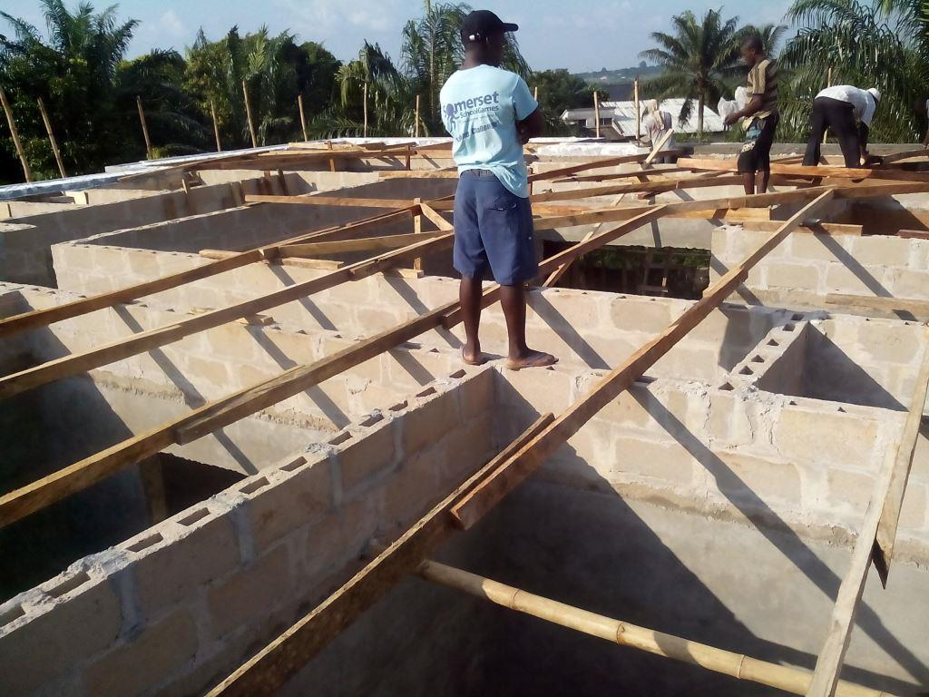
Plate 3.4: Roofing

3.7 CANTILEVER CONSTRUCTION
The cantilever construction phase was a critical structural operation undertaken after the upper floor walls and slab were completed. Cantilevers, being structural projections that extend beyond their supports without visible vertical bracing, are commonly used in modern buildings for features such as balconies, canopies, and staircase landings. The planning and execution of cantilevers require a deep understanding of load distribution, as these structures experience high bending moments and tensile stresses. The process began with the precise setting out of the cantilever zones on the floor slab, based on the architectural and structural drawings. Accurate measurement was vital to ensure that the projection dimensions were maintained, and that alignment with adjacent walls and slabs was achieved.
Once the layout was verified, carpenters proceeded to construct the formwork using quality plywood, timber, and metal supports. Special attention was given to bracing the cantilever formwork to resist downward pressure during concrete placement. After this, reinforcement bars were installed according to the structural engineer’s detailing. These included extended steel bars from the main slab into the cantilever, anchored deep enough to resist pullout or failure. Top bars were particularly emphasized to counter the tensile forces developed along the top of the cantilever. Stirrups and distribution bars were tied in place to provide shear resistance and maintain bar spacing. Any embedded items such as conduit pipes or sleeves for future services were also fixed during this stage and secured properly to avoid displacement during casting.
Concrete was then mixed and poured into the formwork in a continuous operation to avoid cold joints. A mechanical vibrator was used to ensure full compaction and eliminate air pockets. Once poured, the concrete surface was finished smoothly using a steel trowel. The cantilever slab was then cured consistently for a minimum of 7 days to allow adequate strength gain, with wet burlap or regular water spraying used to maintain moisture. The formwork and supporting props were only removed after the concrete had sufficiently cured and gained strength, as verified by the supervising engineer. This careful, step-by-step process ensured that the cantilever was structurally sound, capable of withstanding imposed loads, and aesthetically aligned with the rest of the building’s design.

CHAPTER FOUR

4.0 SUMMARY, CONCLUSION AND RECOMMENDATIONS

4.1 PROBLEMS OBSERVED DURING MY PROGRAM
- The time frame set for the program is too short as some of the aspects of the program where not completed.
- Lack of Financial support from the company to aid transportation to and from training.
- Attentions are not given to the IT students by the workers it is learn if you want to learn or ask if you want to know.

4.2 SUMMARY
One would state that the discipline is the training of the mind and body towards effective performance. The Students Industrial Work Experience Scheme (SIWES) is more or less achieving this fit. As it further builds on the theoretical classrooms leaving a practical approach of the industry and commerce to supply of finished goods and services. This program has enabled the participating students to be practically involved in the day-by-day activities of the industries and commerce.
Emphasis in the observation of industrial safety rules and regulations, time critical operation and proper man-hand management, quality cortices, etc. are daily activity objective. All those aimed at the production of marketable goods and services in the world of work.
However, to consolidate on the gains of this Industrial Training Fund (ITF) higher institution coordinator on SIWES program should be allowed making some suggestion and recommendation.

4.3 CONCLUSION
The SIWES programme has been fulfilling through meeting students form other institution and departments. I had a practical sense of executing building construction. I have a good sense of the importance of any industrial training.

4.4 RECOMMENDATIONS
Having being exposed to a bit of what entail working in an industry related to my course of study under SIWES programme I wish to make this recommendation
- Higher instruction of learning especially either institution and universities should establish link with professional bodies so as to provide space for student on industrial attachment, with the option of gaining employment in future, by doing so, it will go a long way in alleviating suffering and difficulties encountered by student in securing place for individual attachment.
- Orientation and mentorship programs should be introduced at the beginning of the SIWES placement to guide students on expectations, safety protocols, and learning objectives. This will help maximize the learning experience and ensure students are better integrated into the work environment.

REFERENCES
Brown, T. L., & Green, M. D. (2019). The impact of foundation design on structural integrity. Journal of Structural Engineering, 45(3), 225-240.
Edward, B. (2003). The Effect of SIWES on a student, Federal Ministry of Works, Lagos. Nigeria.
Sarduana Local Government Area Secretariat (2024). Ministry of Works, Gembu, Taraba State.
Smith, J. A. (2020). Building structures: An introduction to civil engineering (2nd ed.). McGraw-Hill.
White, P. R., & Black, C. L. (2018). Innovations in sustainable construction materials. In Proceedings of the 10th International Conference on Civil Engineering (pp. 134-141). Engineering Society Press.

